Basic Linux Commands
Linux commands are a type of Unix command or shell procedure. They are the basic tools used to interact with Linux on an individual level. Linux commands are used to perform a variety of tasks, including displaying information about files and directories.

Here are some basic Linux commands used for the Practical lab 1:
- ls Command: Lists the files in the current directory.
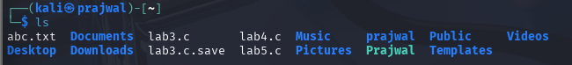

- dir Command: Lists information about the files in current directory.
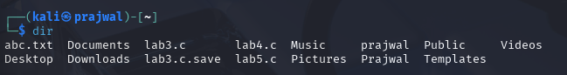

- ls –a Command: Lists the files in the current directory with all the hidden files as well.
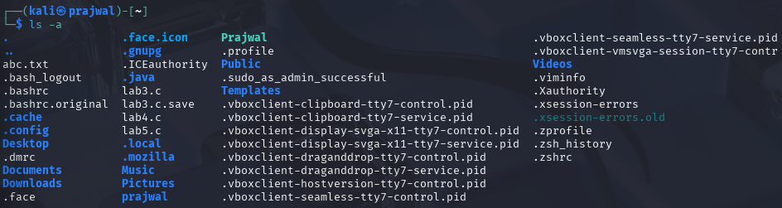

- ls –l Command: It is used to list information about files and directories within the file system.

- ls --help Command: Displays the help guide of the command ls.
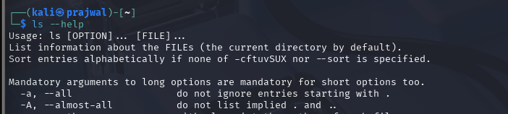

- pwd Command: Is used to print the present working directory.

- cd Command: Is used to change the working directory.
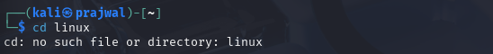

- mkdir Command: Is used to make directories.
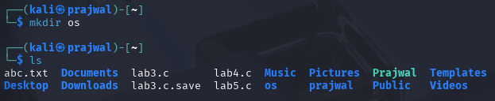

- cd os: changes directory to os in terminal.


- touch Command: used to create files from linux terminal in the working directory.
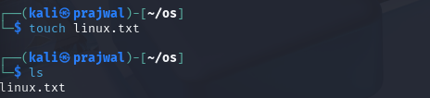

- nano linux.txt: Opens the file “linux.txt” in nano editor.
- cat linux.txt: It is used to display the contain of the linux.txt file in the terminal itself.
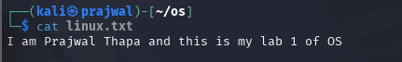

- touch unix.txt: Creates the file named “unix.txt”.
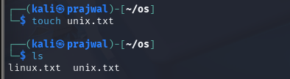

- cat > unix.txt: is used to concatenate text in the file. Exited using Ctrl+c.
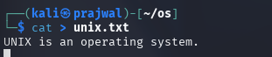

- touch fedora.txt arch.txt debian.txt red_hat.txt: Is used to create multiple files in the working directory.
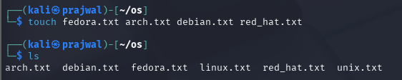
- cp linux.txt fedora.txt: Copies the content of file linux.txt into file fedora.txt.
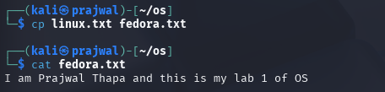

- cd.. Command: changes to the directory immediately above the current directory, its parent directory.
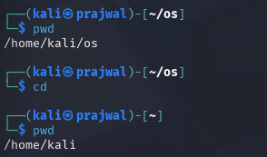
- cd os: change working directory to “os”.
- rm fedora.txt: removes the file fedora.txt.
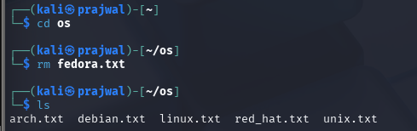

- rm arch.txt linux.txt: used to remove multiple file at the same time. 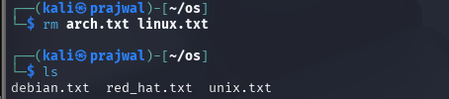

- rm *.txt: removes all file with the extension .txt (text files).
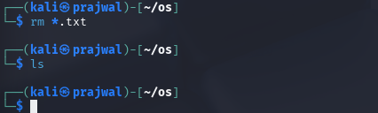

- cd ..
- rmdir os: removes the directory named “os”(only if it is empty).
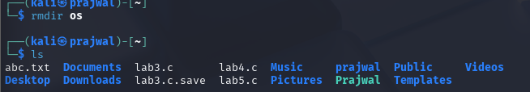
- rm –rf ubuntu: removes the directory “ubuntu” and it’s content recursively and forcefully.
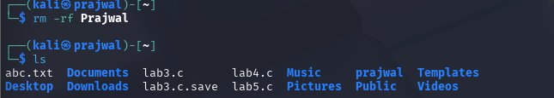

Conclusion

In conclusion, this lab session on basic Linux commands provided a fundamental understanding of the essential commands needed to navigate and manage a Linux system. We covered various commands for file and directory operations, permissions, process management. By practicing these commands, we have built a strong foundation for more advanced Linux system administration tasks.

